

**Luke Emotional Expression Questionnaire**

**Age: Gender: User Number:**

For each of Luke’s emotional expressions:

1. Indicate the level of valence and arousal you believe Luke has (circle one image). Valence is a measure of your overall positive or negative feelings. Arousal is measure of your overall intensity of feelings.
2. Provide the name of the emotion you believe Luke has. You can specify the same emotion multiple times.
3. Indicate whether or not the eye colour of the robot matches the emotion you believe Luke has (circle yes or no).

|  |  |  |  |  |
| --- | --- | --- | --- | --- |
| High Valence | ←→ | Neutral | ←→ | Low Valence |

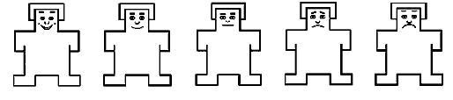

|  |  |  |  |  |
| --- | --- | --- | --- | --- |
| High Arousal | ←→ | Neutral | ←→ | Low Arousal |

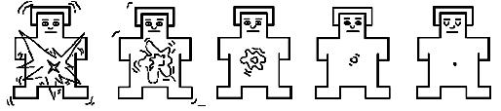

Expression Name: _____________________

Eye colour matches the emotion: Yes No



|  |  |  |  |  |
| --- | --- | --- | --- | --- |
| High Valence | ←→ | Neutral | ←→ | Low Valence |



|  |  |  |  |  |
| --- | --- | --- | --- | --- |
| High Arousal | ←→ | Neutral | ←→ | Low Arousal |



Expression Name: _____________________

Eye colour matches the emotion: Yes No

|  |  |  |  |  |
| --- | --- | --- | --- | --- |
| High Valence | ←→ | Neutral | ←→ | Low Valence |



|  |  |  |  |  |
| --- | --- | --- | --- | --- |
| High Arousal | ←→ | Neutral | ←→ | Low Arousal |



Expression Name: _____________________

Eye colour matches the emotion: Yes No



|  |  |  |  |  |
| --- | --- | --- | --- | --- |
| High Valence | ←→ | Neutral | ←→ | Low Valence |



|  |  |  |  |  |
| --- | --- | --- | --- | --- |
| High Arousal | ←→ | Neutral | ←→ | Low Arousal |



Expression Name: _____________________

Eye colour matches the emotion: Yes No

|  |  |  |  |  |
| --- | --- | --- | --- | --- |
| High Valence | ←→ | Neutral | ←→ | Low Valence |



|  |  |  |  |  |
| --- | --- | --- | --- | --- |
| High Arousal | ←→ | Neutral | ←→ | Low Arousal |



Expression Name: _____________________

Eye colour matches the emotion: Yes No



|  |  |  |  |  |
| --- | --- | --- | --- | --- |
| High Valence | ←→ | Neutral | ←→ | Low Valence |



|  |  |  |  |  |
| --- | --- | --- | --- | --- |
| High Arousal | ←→ | Neutral | ←→ | Low Arousal |



Expression Name: _____________________

Eye colour matches the emotion: Yes No

|  |  |  |  |  |
| --- | --- | --- | --- | --- |
| High Valence | ←→ | Neutral | ←→ | Low Valence |



|  |  |  |  |  |
| --- | --- | --- | --- | --- |
| High Arousal | ←→ | Neutral | ←→ | Low Arousal |



Expression Name: _____________________

Eye colour matches the emotion: Yes No



|  |  |  |  |  |
| --- | --- | --- | --- | --- |
| High Valence | ←→ | Neutral | ←→ | Low Valence |



|  |  |  |  |  |
| --- | --- | --- | --- | --- |
| High Arousal | ←→ | Neutral | ←→ | Low Arousal |



Expression Name: _____________________

Eye colour matches the emotion: Yes No

|  |  |  |  |  |
| --- | --- | --- | --- | --- |
| High Valence | ←→ | Neutral | ←→ | Low Valence |



|  |  |  |  |  |
| --- | --- | --- | --- | --- |
| High Arousal | ←→ | Neutral | ←→ | Low Arousal |



Expression Name: _____________________

Eye colour matches the emotion: Yes No



|  |  |  |  |  |
| --- | --- | --- | --- | --- |
| High Valence | ←→ | Neutral | ←→ | Low Valence |



|  |  |  |  |  |
| --- | --- | --- | --- | --- |
| High Arousal | ←→ | Neutral | ←→ | Low Arousal |



Expression Name: _____________________

Eye colour matches the emotion: Yes No